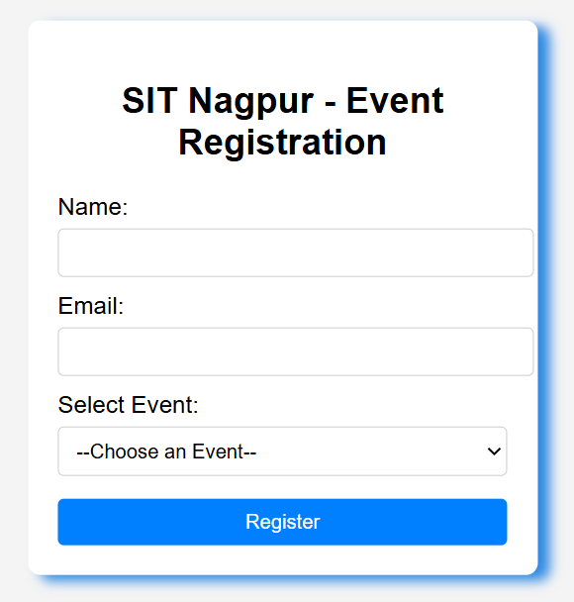
Practical: - To create a registration page for SIT Nagpur event
<!DOCTYPE html>
<html lang="en">
<head>
<meta charset="UTF-8">
<meta name="viewport" content="width=device-width, initial-scale=1.0">
<title>SIT Nagpur - Event Registration</title>
<style>
body {
font-family: Arial, sans-serif;
background-color: #f4f4f4;
margin: 0;
}
.form-container {
background-color: #fff;
padding: 20px;
border-radius: 8px;
width: 300px;
box-shadow: 8px 4px 8px rgba(25, 125, 225, 0.9);
position: absolute;
top: 50%;
left: 50%;
transform: translate(-50%, -50%);
}
h2 {
text-align: center;
margin-bottom: 20px;
}
label {
display: block;
margin-top: 10px;
}
input, select {
width: 100%;
padding: 8px;
margin-top: 5px;
border: 1px solid #ccc;
border-radius: 4px;
}
input[type="submit"] {
background-color: #007fff;
color: #fff;
border: none;
cursor: pointer;
margin-top: 15px;
}
input[type="submit"]:hover {
background-color: #005fcc;
}
</style>
</head>
<body>
<div class="form-container">
<h2>SIT Nagpur - Event Registration</h2>
<form>
<!-- Name -->
<label for="name">Name:</label>
<input type="text" id="name" name="name" required>
<!-- Email -->
<label for="email">Email:</label>
<input type="email" id="email" name="email" required>
<!-- Event Dropdown -->
<label for="event">Select Event:</label>
<select id="event" name="event" required>
<option value="">--Choose an Event--</option>
<option value="hackathon">Hackathon</option>
<option value="webdesign">Web Design</option>
</select>
<!-- Submit -->
<input type="submit" value="Register">
</form>
</div>
</body>
</html>

